**Homework 5**

**Spell Checking, AutoComplete and Snippets**

NYPost Search Engine

By: Mukesh Kumar Dangi

**ReadMe: Tool and Steps Followed in the project**

We used HW4 as based for this project and added 3 more functionalities 1. Spell correction, auto suggestion and snippet extraction.

GitHub: <https://github.com/mukeshkdangi/nypost-searchengine>

**Step 1: Created Big.txt:**

Extracted text from NyPost crawled data sets using Tika TagSoup parser written in Java.

and added the text into Big.txt, which is the vocabulary for spell check and auto suggest.

**Step 2: Spell Correction:**

Used spelling-corrector NodeJS module for spelling correction. We trained this module for out custom spell check. Following Steps were followed to initialize and train the module:

*let SpellCorrector = require('spelling-corrector');*

*let spellCorrector = new SpellCorrector();*

***spellCorrector****.****loadDictionary****('/Users/mukesh/Office/Tools/Solr/solr-7.5.0/big.txt');*

When a user inputs an incorrect query and submits the page, the program checks to see if it’s a valid word or not. If it’s a valid word corresponding results are displayed else a phrase with **“Did you mean <correct_word>”.**  When user clicks on correct word, results gets displayed accordingly.

Spell corrector: 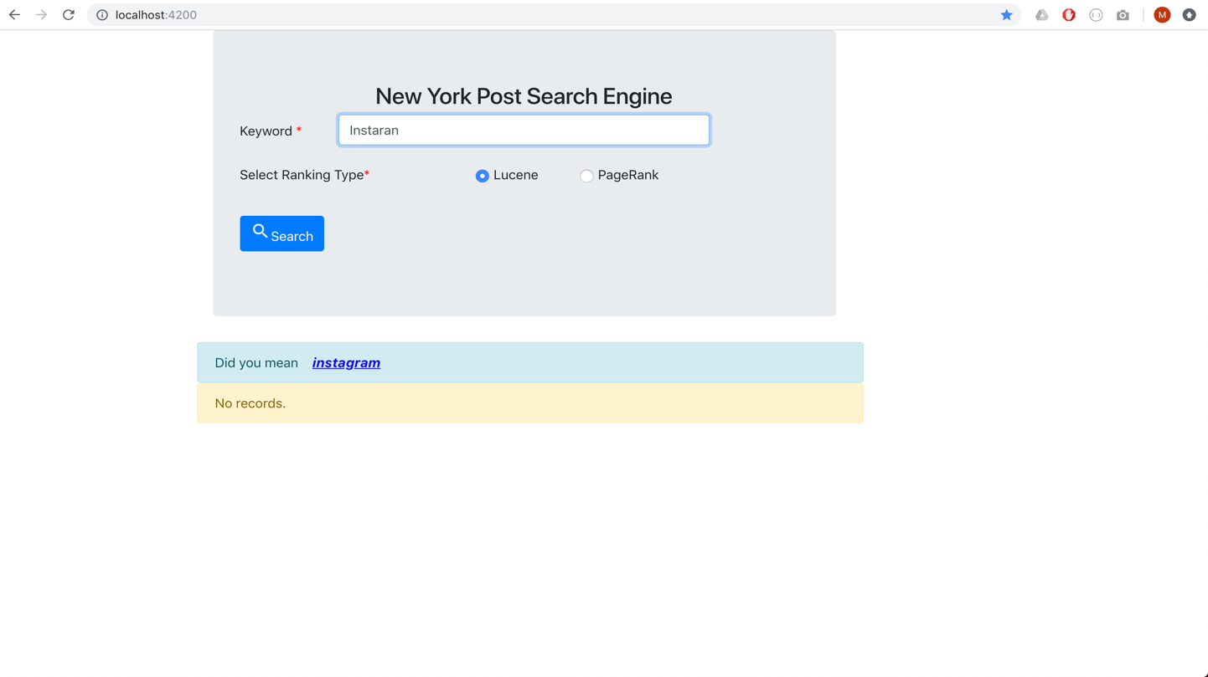

**Step 3: Auto complete:**

I have implemented autosuggestion using **Angular 7** following libraries

*MatAutocompleteModule, MatOptionModule, BrowserAnimationsModule, BrowserModule, FormsModule, HttpClientModule*

Called the autocomplete API on key down or any text change *(****keydown****)="searchAutoCompelete($event)* from the main page.

Then called 'http://localhost:8983/solr/nypost/suggest?q=' + req.query.keyword API for suggestion for the entered key.

http://localhost:8983/solr/nypost/suggest?q=' + req.query.keyword and sent it back to the home page.

The results of auto complete are displayed in a dropdown list.For Multiple keywords I appednded the last space indexed word to the drop-down list.

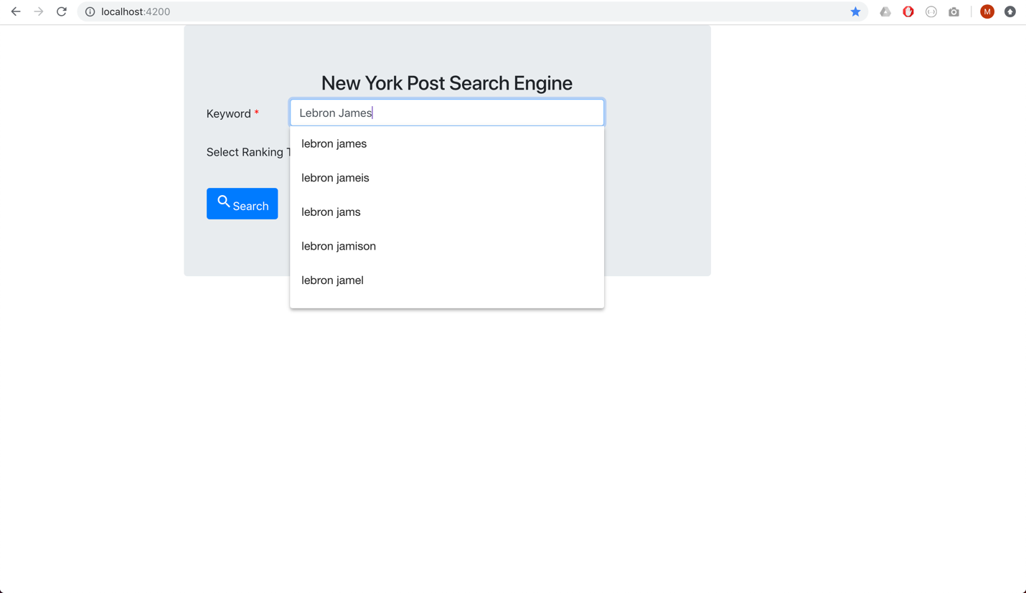

4. Analysis of the results:

1. **SPELL CORRECTION:**

|  |  |
| --- | --- |
| **Incorrect Word** | **Correct Word** |
| instagrm | instagram |
| Donal Trmp | donal trump |
| Snapcht | snapchat |
| north koea | north korea |
| Illegal immgraton | illegal immigration |

1. **AUTO-COMPLETE:**

|  |  |
| --- | --- |
| **Prefix** | **Autocompletion** |
| kor | kor  korea  kerry  karol  kardashian  korean |
| cali | cali  click  called  claims  clinton |
| Immi | immi  immediately  immigration  immigrant  immigrants |
| face | face  facebook  faces  facing  fact |
| inst | inst  instagram  instagram.com  istax  inside |

**3. Snippet**

For snippet, we first extracted the body text for all the files and maintained a map of doc id and corresponding text. Next, we searched 10 docs for every term user entered. And retrieved the 10 docs with URL, doc id, title and snippet. For multiword query, we tried to match the whole query term in the 10 docs returned from Solr and if found we returned otherwise we broke the query terms into pieces and tried to look for individual term in the docs and returned results.

